**EXPERIMENT No. 7**

**Study of a non-Catalytic Gas-Solid Reaction by Thermogravimetric Technique**

**Objective:**

To determine the reaction rate constant for the decomposition of cylindrical sodium bicarbonate pellet and find out the activation energy in a temperature range of 100 to 250°C. The stoichiometric equation:

**2NaHCO3 =Na2CO3 + CO2 + H20 -- (1)**

**Theoretical background:**

For the above reaction the unreacted core model which has been found to satisfy most of the non-catalytic gas-solid reaction is applied. In the case of bicarbonate decomposition, chemical resistance at the interface, diffusional resistance of the boundary layer and the product layer may individually or simultaneously control the reaction rate. The previous studies have shown that the effect of sweeping gas flow rate (air) is negligible on the conversion at different temperatures. So at low conversion (thin product layer) it may be concluded that the two diffusional resistances, e.g. gas film diffusion and ash layer diffusion are absent and the reaction rate is controlled by the chemical resistance. Lievenspiel's equation may be used to convert the weight-loss at ny instance into the weight-loss per unit area of interface by introducing a dimensionless factor f which represents the fractional thickness of the reacted solid at any instance. When f attains the value of the ration of length to diameter (a) of the

cylindrical reactant pellet, the reaction is complete.

The rate equation may be written as:

**Rodof = kt -- (2)**

Where,

Ro = Initial radius of the pellet, cm

do = Density of the reactant pellet, gm/cc

t = Reaction time

k = Modified rate constant

The spherical pellet and the cylindrical pellet with same length and diameter, the

relation between conversion x and f is

**f = 1 - (1 - x)^1/3 -- (3)**

For cylindrical pellet with any ratio of length/diameter, reaction conversion is given

by:

**x =1-(a-f)*(1-f)^2/a -- (4)**

So for any value of x we can get f from the above relation and calculate Rodof for each time t. Under the isothermal condition Rodof vs t plot will give straight line for chemical resistance control. At different temperatures, we are expected to get different Rodof vs t straight lines from the slope w of which we can find out the activation energy by plotting Ink vs 1/T.

**Apparatus:**

A thermogravimetric set up used in the present study consisting of the following:

1. An analytical chainometric (keroy) balance from the left pan of which is suspended a Pt wire carrying sample holder, made of 200 mesh SS Screen.
2. A tube furnace consisting of mullite tube of length 45.72 cm and diameter 5.08 cm. The furnace bottom is packed with quartz particle made up to some height for preheating the sweeping gas.
3. A Voltage stabilizer and control device are introduced to avoid the fluctuations

in voltage and temperature.

**Preparation of the solid sample:**

The pellets of any length and diameter are made by putting AR Grade sodium bicarbonate powder in a cylindrical metallic die and pressing the sample in a laboratory hydraulic press. The pressure may be varied as we desire.

**Experimental Procedure:**

(1) The calibration of the thermocouple should be done with pure solid substances having definite melting point.

(2) Two hours before the actual experiment. The heating of furnace is started. At the same time the sweeping gas flow rate of desired quantity is usually maintained.

(3) The cylindrical pellet is then placed into the basket and lowered into the reactor (just above the thermocouple sheath).

(4)From loss of the pellet, the conversion x is calculated

**x = ΔW / ∑ΔW**

Where AW = total weight loss = W(0) - W(t)

(5) The temperature recorded by the thermocouple near the basket is assumed to be the pellet temperature. Alternatively, the reaction can be carried out in non-isothermal condition within the range when the temperature is linear with time.

**Diagram**

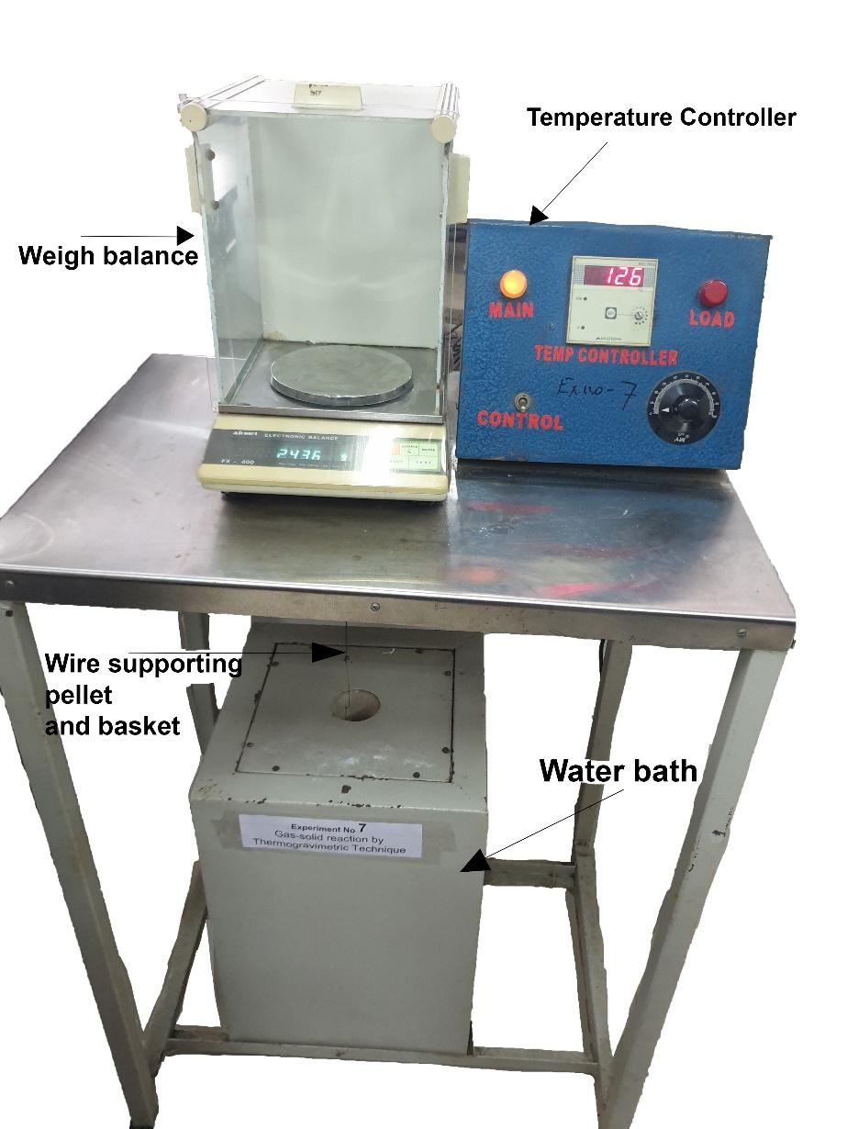

### Observation and Calculations

|  |  |  |  |  |  |  |  |
| --- | --- | --- | --- | --- | --- | --- | --- |
| **time (min)** | **weight (g)** | **Δ weight** | **x** | **f** | **k** | **Rodof** | **initial weight (gm)** |
| 1 | 3.437 | 0.022 | 0.001207596882 | 0.0004026944351 | 0.0005963636913 | 0.0005963636913 | 3.459 |
| 2 | 3.416 | 0.043 | 0.002360302997 | 0.000787387482 | 0.0005830342616 | 0.001166068523 | 3.459 |
| 3 | 3.319 | 0.14 | 0.007684707432 | 0.002568158938 | 0.001267757561 | 0.003803272682 | 3.459 |
| 4 | 3.23 | 0.229 | 0.01256998573 | 0.00420767494 | 0.001557821725 | 0.006231286901 | 3.459 |
| 5 | 3.14 | 0.319 | 0.01751015479 | 0.005871120865 | 0.00173894795 | 0.008694739748 | 3.459 |
| 6 | 3.06 | 0.399 | 0.02190141618 | 0.007354427064 | 0.001815236272 | 0.01089141763 | 3.459 |
| 7 | 2.98 | 0.479 | 0.02629267757 | 0.008842179557 | 0.001870668598 | 0.01309468018 | 3.459 |
| 8 | 2.911 | 0.548 | 0.03008014052 | 0.010128963 | 0.001875040117 | 0.01500032093 | 3.459 |
| 9 | 2.895 | 0.564 | 0.0309583928 | 0.01042782585 | 0.00171587966 | 0.01544291694 | 3.459 |
| 10 | 2.782 | 0.677 | 0.03716104951 | 0.0125437031 | 0.001857639051 | 0.01857639051 | 3.459 |
| 11 | 2.718 | 0.741 | 0.04067405862 | 0.01374610926 | 0.001850643101 | 0.02035707411 | 3.459 |
| 12 | 2.653 | 0.806 | 0.0442419585 | 0.01497031139 | 0.001847503008 | 0.02217003609 | 3.459 |
| 13 | 2.58 | 0.879 | 0.04824898452 | 0.01634882224 | 0.00186242454 | 0.02421151903 | 3.459 |
| 14 | 2.522 | 0.937 | 0.05143264903 | 0.01744683828 | 0.001845543415 | 0.0258376078 | 3.459 |
| 15 | 2.471 | 0.988 | 0.05423207816 | 0.01841436693 | 0.001818030228 | 0.02727045342 | 3.459 |
| 16 | 2.429 | 1.03 | 0.05653749039 | 0.0192125898 | 0.001778285527 | 0.02845256843 | 3.459 |
| 17 | 2.38 | 1.079 | 0.059227138 | 0.02014549501 | 0.001754949355 | 0.02983413904 | 3.459 |
| 18 | 2.339 | 1.12 | 0.06147765946 | 0.02092745647 | 0.001721787332 | 0.03099217198 | 3.459 |
| 19 | 2.304 | 1.155 | 0.06339883632 | 0.02159597419 | 0.001683273804 | 0.03198220228 | 3.459 |
| 20 | 2.281 | 1.178 | 0.06466132397 | 0.02203578374 | 0.00163167655 | 0.032633531 | 3.459 |
| 21 | 2.262 | 1.197 | 0.06570424855 | 0.02239940327 | 0.00157962035 | 0.03317202736 | 3.459 |
| 22 | 2.237 | 1.222 | 0.06707651773 | 0.02287826253 | 0.001540053913 | 0.03388118609 | 3.459 |
| 23 | 2.226 | 1.233 | 0.06768031617 | 0.02308910937 | 0.001486671141 | 0.03419343625 | 3.459 |
| 24 | 2.226 | 1.233 | 0.06768031617 | 0.02308910937 | 0.00142472651 | 0.03419343625 | 3.459 |
|  | ∑ΔW= | 18.218 |  |  |  |  |  |

|  |  |
| --- | --- |
| diameter (cm) | 1.71 |
| height (cm) | 0.87 |
| volume (cm^3) | 1.997014095 |
| density (g/cm^3) | 1.732085922 |
| temp | 124 |

|  |  |
| --- | --- |
| **ln(k)** | **1/t** |
| -7.424659857 | 1 |
| -7.447264606 | 0.5 |
| -6.670505639 | 0.3333333333 |
| -6.464466763 | 0.25 |
| -6.354474975 | 0.2 |
| -6.311539642 | 0.1666666667 |
| -6.281459373 | 0.1428571429 |
| -6.279125224 | 0.125 |
| -6.367829409 | 0.1111111111 |
| -6.288448925 | 0.1 |
| -6.292222078 | 0.09090909091 |
| -6.293920277 | 0.08333333333 |
| -6.285876124 | 0.07692307692 |
| -6.294981511 | 0.07142857143 |
| -6.310001656 | 0.06666666667 |
| -6.332105566 | 0.0625 |
| -6.34531528 | 0.05882352941 |
| -6.364392381 | 0.05555555556 |
| -6.387014689 | 0.05263157895 |
| -6.418147235 | 0.05 |
| -6.450570745 | 0.04761904762 |
| -6.475937855 | 0.04545454545 |
| -6.511215792 | 0.04347826087 |
| -6.553775406 | 0.04166666667 |

Temp: 145oC

|  |  |  |  |  |  |  |  |
| --- | --- | --- | --- | --- | --- | --- | --- |
| **time(min)** | **weight (g)** | **Δ weight** | **x** | **f** | **k** | **Rodof** | **initial weight (gm)** |
| 1 | 3.239 | 0.04 | 0.002488800398 | 0.0008302893223 | 0.001186106947 | 0.001186106947 | 3.279 |
| 2 | 3.165 | 0.114 | 0.007093081135 | 0.002369972712 | 0.00169280817 | 0.003385616341 | 3.279 |
| 3 | 3.001 | 0.278 | 0.01729716277 | 0.005799287646 | 0.002761517453 | 0.00828455236 | 3.279 |
| 4 | 2.935 | 0.344 | 0.02140368342 | 0.007186077151 | 0.00256641143 | 0.01026564572 | 3.279 |
| 5 | 2.856 | 0.423 | 0.02631906421 | 0.008851132816 | 0.002528851049 | 0.01264425525 | 3.279 |
| 6 | 2.761 | 0.518 | 0.03222996516 | 0.0108608528 | 0.0025858723 | 0.0155152338 | 3.279 |
| 7 | 2.661 | 0.618 | 0.03845196615 | 0.01298520784 | 0.002649996265 | 0.01854997386 | 3.279 |
| 8 | 2.557 | 0.722 | 0.04492284719 | 0.01520428096 | 0.002715002889 | 0.02172002312 | 3.279 |
| 9 | 2.509 | 0.77 | 0.04790940767 | 0.01623184996 | 0.002576439251 | 0.02318795326 | 3.279 |
| 10 | 2.427 | 0.852 | 0.05301144848 | 0.01799226286 | 0.002570278503 | 0.02570278503 | 3.279 |
| 11 | 2.316 | 0.963 | 0.05991786959 | 0.02038536239 | 0.002647403556 | 0.02912143912 | 3.279 |
| 12 | 2.292 | 0.987 | 0.06141114983 | 0.02090432926 | 0.002488567287 | 0.02986280744 | 3.279 |
| 13 | 2.198 | 1.081 | 0.06725983076 | 0.02294226595 | 0.002521084221 | 0.03277409488 | 3.279 |
| 14 | 2.152 | 1.127 | 0.07012195122 | 0.02394265964 | 0.002443085988 | 0.03420320383 | 3.279 |
| 15 | 2.008 | 1.271 | 0.07908163265 | 0.02708766045 | 0.002579732259 | 0.03869598389 | 3.279 |
| 16 | 2.087 | 1.192 | 0.07416625187 | 0.02535976521 | 0.002264225319 | 0.0362276051 | 3.279 |
| 17 | 2.086 | 1.193 | 0.07422847188 | 0.02538159904 | 0.002132870338 | 0.03625879574 | 3.279 |
| 18 | 2.086 | 1.193 | 0.07422847188 | 0.02538159904 | 0.002014377541 | 0.03625879574 | 3.279 |
| 19 | 2.086 | 1.193 | 0.07422847188 | 0.02538159904 | 0.00190835767 | 0.03625879574 | 3.279 |
| 20 | 2.086 | 1.193 | 0.07422847188 | 0.02538159904 | 0.001812939787 | 0.03625879574 | 3.279 |

|  |  |
| --- | --- |
| diameter(cm) | 1.7 |
| height (cm) | 0.86 |
| volume (cm^3) | 1.951039 |
| density (g/cm^3) | 1.68064298 |
| temp | 145 |

|  |  |
| --- | --- |
| **ln(k)** | **1/t** |
| -6.737078808 | 1 |
| -6.38136649 | 0.5 |
| -5.891974948 | 0.3333333333 |
| -5.965246686 | 0.25 |
| -5.97999021 | 0.2 |
| -5.957692381 | 0.1666666667 |
| -5.933197048 | 0.1428571429 |
| -5.908962261 | 0.125 |
| -5.961346969 | 0.1111111111 |
| -5.963741019 | 0.1 |
| -5.934175909 | 0.09090909091 |
| -5.996048121 | 0.08333333333 |
| -5.983066223 | 0.07692307692 |
| -6.01449329 | 0.07142857143 |
| -5.960069661 | 0.06666666667 |
| -6.090522601 | 0.0625 |
| -6.15028663 | 0.05882352941 |
| -6.207445044 | 0.05555555556 |
| -6.261512265 | 0.05263157895 |
| -6.31280556 | 0.05 |

Temp: 165oC

|  |  |  |  |  |  |  |  |
| --- | --- | --- | --- | --- | --- | --- | --- |
| **time(min)** | **weight (g)** | **Δ weight** | **x** | **f** | **k** | **Rodof** | **initial weight(in gm)** |
| 1 | 3.557 | 0.054 | 0.003467539973 | 0.001157185219 | 0.001778619255 | 0.001778619255 | 3.611 |
| 2 | 3.415 | 0.196 | 0.01258588583 | 0.004213019886 | 0.003237752336 | 0.006475504673 | 3.611 |
| 3 | 3.325 | 0.286 | 0.01836511912 | 0.006159568761 | 0.003155797771 | 0.009467393312 | 3.611 |
| 4 | 3.177 | 0.434 | 0.02786874719 | 0.009377240175 | 0.003603256347 | 0.01441302539 | 3.611 |
| 5 | 3.051 | 0.56 | 0.03595967379 | 0.01213317651 | 0.003729792089 | 0.01864896044 | 3.611 |
| 6 | 2.955 | 0.656 | 0.0421241893 | 0.01424330498 | 0.003648712423 | 0.02189227454 | 3.611 |
| 7 | 2.863 | 0.748 | 0.04803185 | 0.01627402383 | 0.003573362039 | 0.02501353428 | 3.611 |
| 8 | 2.776 | 0.835 | 0.05361844218 | 0.01820212104 | 0.003497132789 | 0.02797706231 | 3.611 |
| 9 | 2.697 | 0.914 | 0.05869132473 | 0.0199595063 | 0.003408689143 | 0.03067820229 | 3.611 |
| 10 | 2.57 | 1.041 | 0.06684646504 | 0.0227979519 | 0.003504095591 | 0.03504095591 | 3.611 |
| 11 | 2.535 | 1.076 | 0.06909394465 | 0.02358310574 | 0.003295250429 | 0.03624775471 | 3.611 |
| 12 | 2.461 | 1.15 | 0.07384575868 | 0.02524731539 | 0.00323380681 | 0.03880568172 | 3.611 |
| 13 | 2.409 | 1.202 | 0.07718487125 | 0.0264201684 | 0.003123721747 | 0.04060838272 | 3.611 |
| 14 | 2.366 | 1.245 | 0.07994606049 | 0.02739216656 | 0.003007311812 | 0.04210236536 | 3.611 |
| 15 | 2.337 | 1.274 | 0.08180825788 | 0.02804879875 | 0.002874108237 | 0.04311162355 | 3.611 |
| 16 | 2.311 | 1.3 | 0.08347781417 | 0.02863825869 | 0.002751102282 | 0.04401763652 | 3.611 |
| 17 | 2.31 | 1.301 | 0.08354202787 | 0.02866094452 | 0.002591323832 | 0.04405250514 | 3.611 |
| 18 | 2.31 | 1.301 | 0.08354202787 | 0.02866094452 | 0.002447361397 | 0.04405250514 | 3.611 |
|  | ∑ΔW= | 15.573 | 1 |  |  |  |  |

|  |  |
| --- | --- |
| diameter(cm) | 1.72 |
| height (cm) | 0.87 |
| volume (cm^3) | 2.02043928 |
| density (g/cm^3) | 1.787235101 |
| temp | 165 |

|  |  |
| --- | --- |
| **ln(k)** | **1/t** |
| -6.331917915 | 1 |
| -5.732875913 | 0.5 |
| -5.758513956 | 0.3333333333 |
| -5.625917302 | 0.25 |
| -5.591402787 | 0.2 |
| -5.613380935 | 0.1666666667 |
| -5.634248379 | 0.1428571429 |
| -5.655811849 | 0.125 |
| -5.681427477 | 0.1111111111 |
| -5.653822826 | 0.1 |
| -5.715273111 | 0.09090909091 |
| -5.734095257 | 0.08333333333 |
| -5.76873012 | 0.07692307692 |
| -5.806708685 | 0.07142857143 |
| -5.852012831 | 0.06666666667 |
| -5.895753618 | 0.0625 |
| -5.955586402 | 0.05882352941 |
| -6.012744816 | 0.05555555556 |

## Result

|  |  |  |  |  |
| --- | --- | --- | --- | --- |
| **Sr. No.** | **Temperature** | **k** | **1/T(K-1)** | **lnK** |
| 1 | 397 | 0.001413 | 0.00252 | -6.56204 |
| 2 | 418 | 0.001965 | 0.00239 | -6.23226 |
| 3 | 438 | 0.002566 | 0.00228 | -5.96541 |

|  |  |
| --- | --- |
| **slope** | -2487.483834 |
| **Ea** | 20.68094059 |

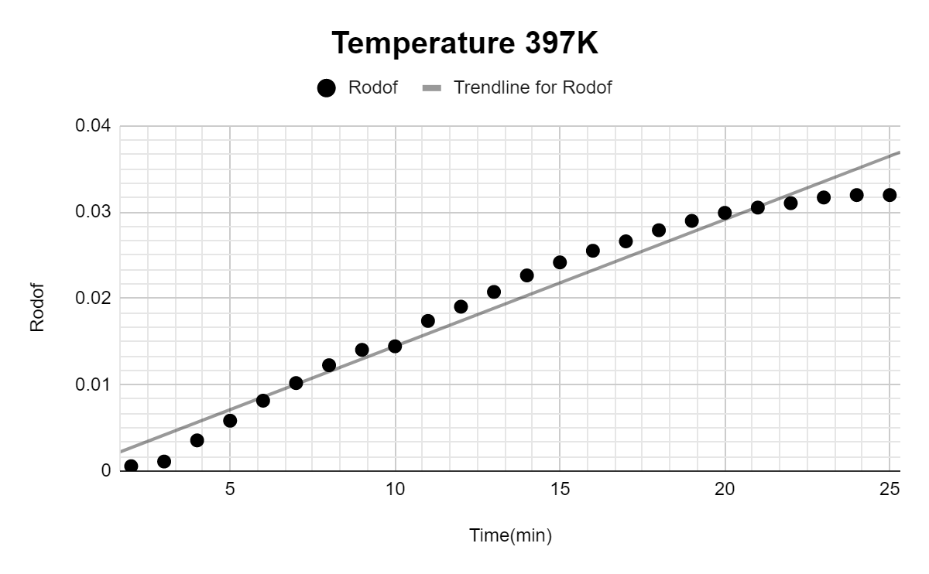

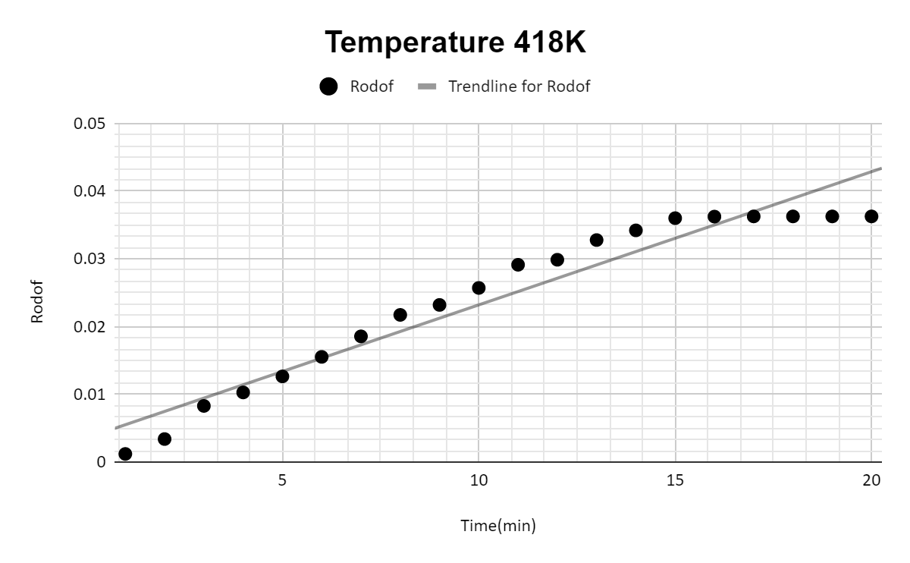

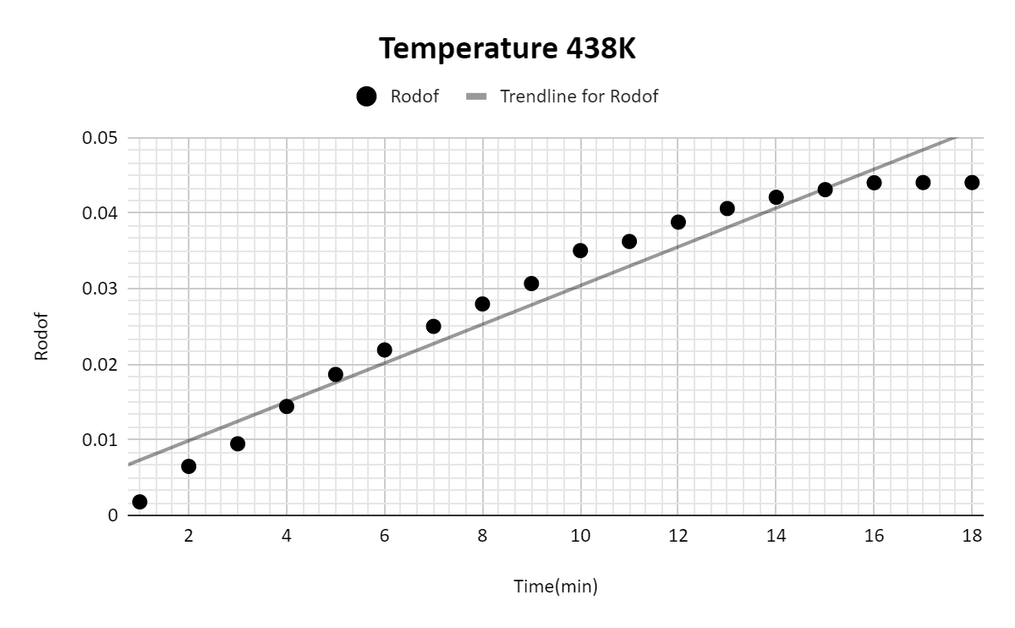

### Discussion

In recent years, the interest in non catalytic heterogeneous gas-solid reactions has increased, partly because of wider commercial application of this type of reaction, and partly because of improved physical and mathematical techniques for analyzing the reaction systems. Although a complete understanding of the reaction mechanisms is not necessary for design purposes, an understanding of the relative contributions of physical diffusion (both external and internal) and of chemical reaction toward the overall mass transfer rate is important, particularly in the case of nonsteady-state reactions occurring in fixed-bed equipment. Zinc, lead, and iron pyrites can be roasted commercially in fixed-bed reactors. Recently, the technique of gas-solid reactions has been used successfully on a small scale for removing sulfur dioxide from flue gases, by reaction with metal oxides at flue gas temperatures (J). Some excellent experimental work has been carried out in the field of solid-gas reactions, but most workers have correlated their kinetic and mass transfer data by empirical or semi empirical means, usually assuming that one of two mechanisms is controlling.

In this experiment for the given unreacted core model which has been found to satisfy most of the non-catalytic gas-solid reaction is applied. In our case of bicarbonate decomposition, chemical resistance at the interface, diffusional resistance of the boundary layer and the product layer are individually or simultaneously control the reaction rate. Studies have shown that the effect of sweeping gas flow rate (air) is negligible on the conversion at different temperatures. So at low conversion (thin product layer) it may be concluded that the two diffusional resistances, e.g. gas film diffusion and ash layer diffusion are absent and the reaction rate is controlled by the chemical resistance. Lievenspiel's equation may be used to convert the weight-loss at ny instance into the weight-loss per unit area of interface by introducing a dimensionless factor f which represents the fractional thickness of the reacted solid at any instance. When f attains the value of the ration of length to diameter (a) of the cylindrical reactant pellet, the reaction is complete.